**Saas project**

Problem Statement

The sales pipeline conversion percentage at Techno Serve (a tech SaaS startup) has dropped from 35% at the end of last fiscal (FY 2017-18) to 25% at present.

Assignment Objective

Understand the problem, come up with a hypothesis for low conversions faced by

Techno Serve, and analyse the dataset provided to arrive at possible solutions to increase it.

# PART I : 1. Understanding the Problem

## Sales Pipeline Conversion at a SaaS Startup

|  |  |  |  |  |  |  |  |  |
| --- | --- | --- | --- | --- | --- | --- | --- | --- |
| **Who?**  A tech SaaS startup,  Techno Serve |  | **What?**  The pipeline conversion for the sales is very less. It has fallen from 35% to 25%. |  | **When?**  From the first quarter  of the fiscal year 2018-  19 |  | **Where?**  Among the possible customers or the leads of the company |  | **How?**  There is an inefficiency in the process followed by the sales team  The product offered is not solving the customer problems |

# PART I : 2. Understanding the Problem

## Sales Pipeline Conversion at a SaaS Startup

|  |  |  |  |  |  |  |
| --- | --- | --- | --- | --- | --- | --- |
| **Situation**   1. What are the products offered by the company? 2. How many clients does Techno Serve has? 3. What is the strength of the employees within the company? 4. What is the strength of the   Sales team at Techno Serve? |  | **Problem**   1. How does Techno Serve identify the leads in the market? 2. On an average, how many days does it take to convert a lead into a client? 3. Is the team skilled to sell the products in the market? 4. Does the sales team have knowledge about the products that are offered to the customers? |  | **Implication**   1. What is the impact of low sales pipeline conversion on the profits of the company? 2. Does low pipeline conversion impact your targets of the future? 3. What is the impact of the problem on the sales force? Are they able to perform as per the expectations? 4. How does low pipeline conversion restrict your growth in the market? |  | **Need-Payoff**   1. What is the increase in revenue expected if the problem is solved? 2. How will the employees benefit if the problem is solved? 3. How will you use the extra revenue generated from the increased sales? 4. Will there be an increase in the market share of the company? |

## Sales Pipeline Conversion at a SaaS Startup

**Framework Used**

Issue tree framework in conjugation with the 5C Framework

**Reason for using the selected framework**

It is easy to cover all the domains using the above mentioned frameworks

**How have you used the framework here**

The problem has been divided into the five C’s in the framework and then, each C is again branched using the issue tree framework.

## Sales Pipeline Conversion at a SaaS Startup

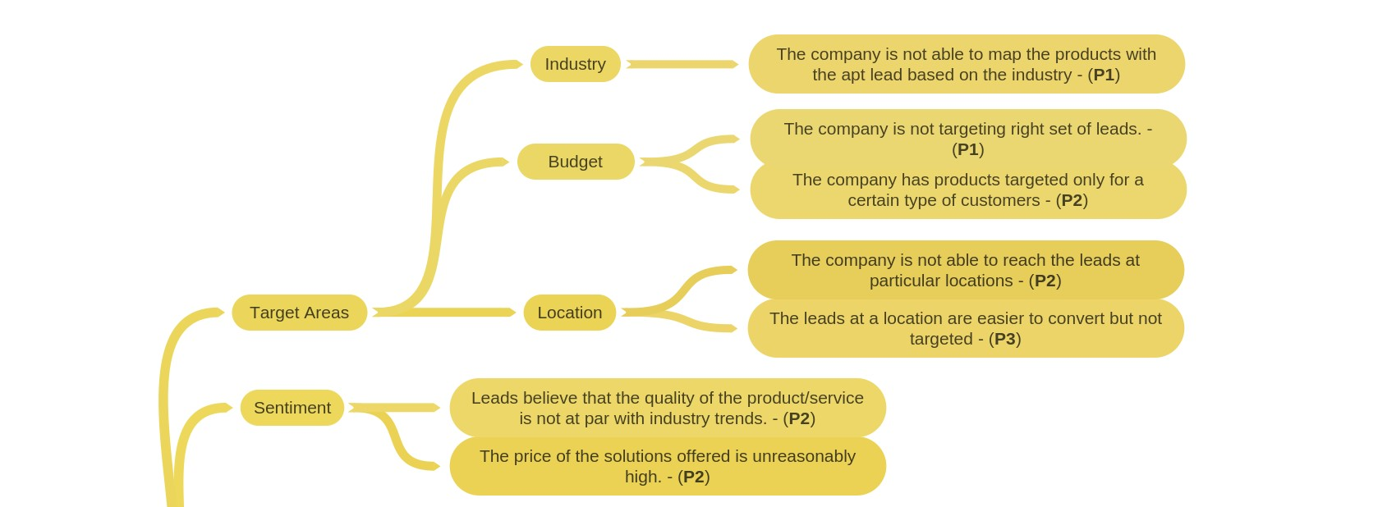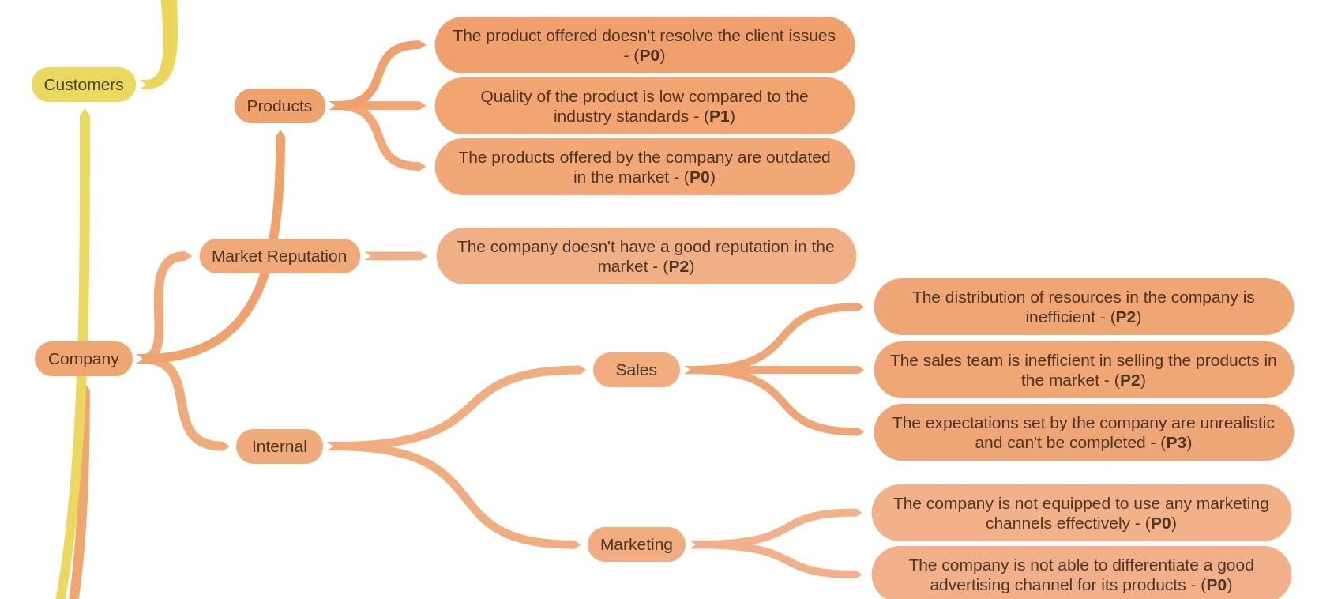

Sales Pipeline Conversion at a SaaS Startup

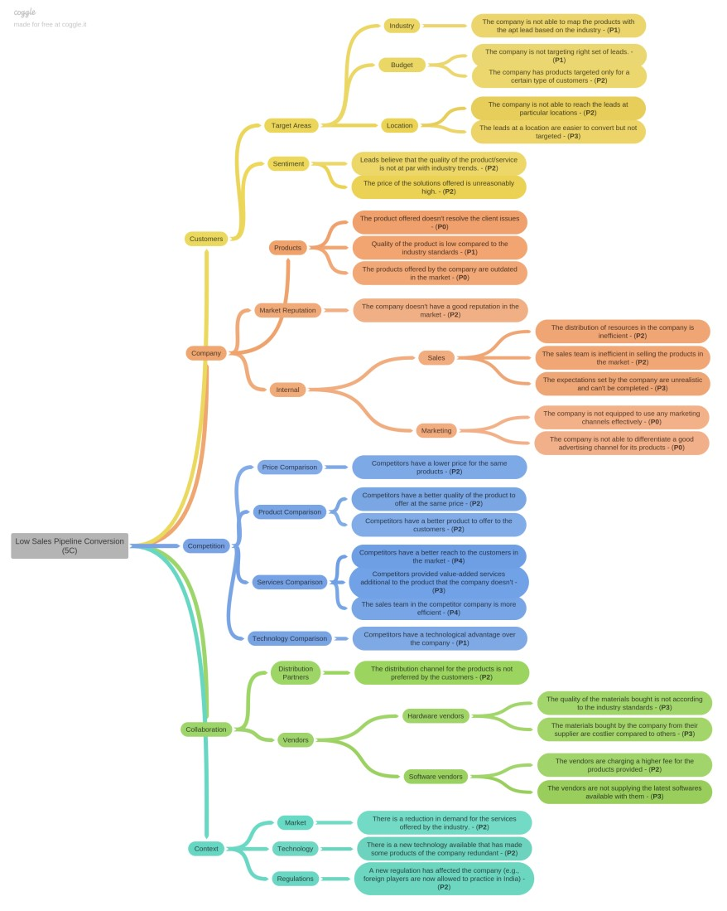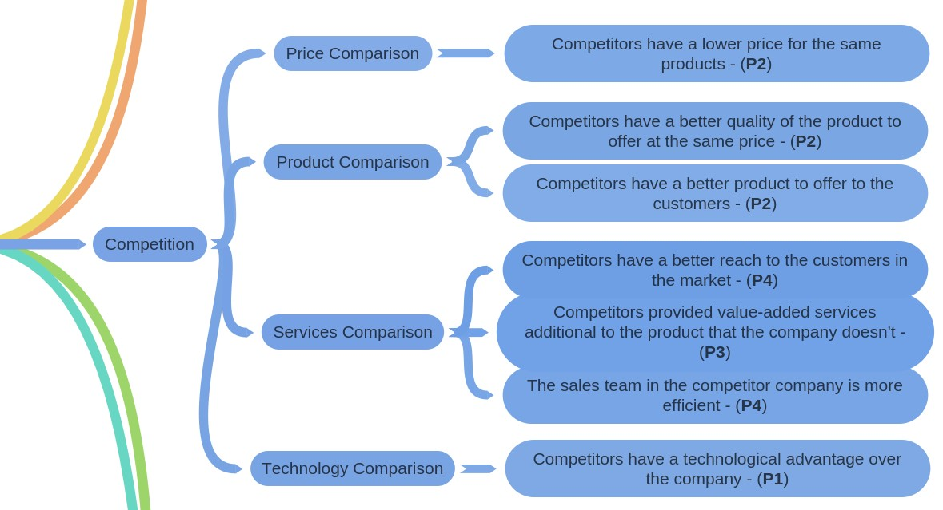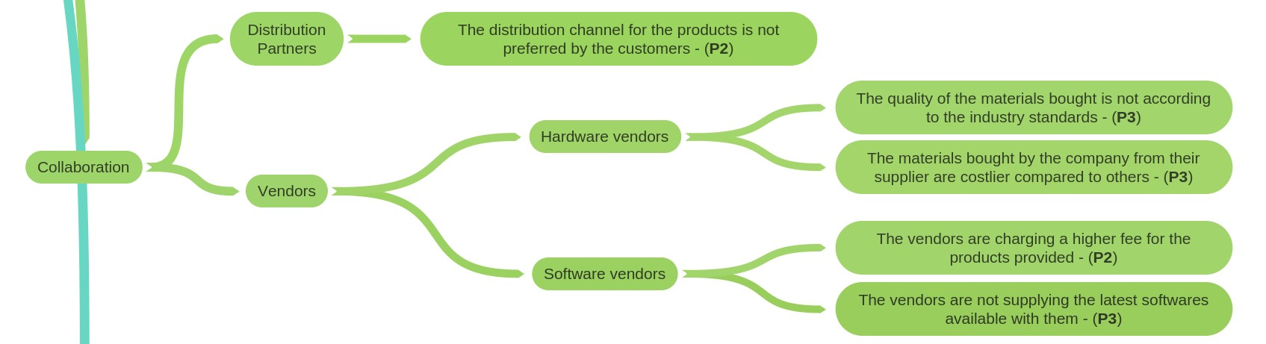

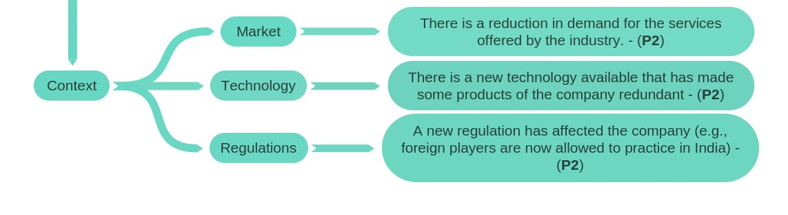Sales Pipeline Conversion at a SaaS Startup

## Sales Pipeline Conversion at a SaaS Startup

**Branch 1: Low Sales Pipeline Conversion – Customer – Targeting - Industry**

The company is not able to map the products with the apt lead based on the industry - (**P1**)

### Branch 2: Low Sales Pipeline Conversion – Customer – Targeting - Budget

The company is not targeting right set of leads. - (**P1**)

The company has products targeted only for a certain type of customers - (**P2**)

## Sales Pipeline Conversion at a SaaS Startup

### Branch 3: Low Sales Pipeline Conversion – Customer – Targeting - Location

The company is not able to reach the leads at particular locations - (**P2**)

The leads at a location are easier to convert but not targeted - (**P3**)

### Branch 4: Low Sales Pipeline Conversion – Customer – Sentiment

Leads believe that the quality of the product/service is not at par with industry trends. - (**P2**)

The price of the solutions offered is unreasonably high. - (**P2**)

## Sales Pipeline Conversion at a SaaS Startup

### Branch 5: Low Sales Pipeline Conversion – Company - Products

The product offered doesn't resolve the client issues - (**P0**)

Quality of the product is low compared to the industry standards - (**P1**)

The products offered by the company are outdated in the market - (**P0**)

**Branch 6: Low Sales Pipeline Conversion – Company – Market Reputation**

The company doesn't have a good reputation in the market - (**P2**)

## Sales Pipeline Conversion at a SaaS Startup

### Branch 7: Low Sales Pipeline Conversion – Company – Internal – Sales

The distribution of resources in the company is inefficient - (**P2**)

The sales team is inefficient in selling the products in the market - (**P2**)

The expectations set by the company are unrealistic and can't be completed - (**P3**)

### Branch 8: Low Sales Pipeline Conversion – Company – Internal – Marketing

The company is not equipped to use any marketing channels effectively - (**P0**)

The company is not able to differentiate a good advertising channel for its products - (**P0**)

## Sales Pipeline Conversion at a SaaS Startup

**Branch 9: Low Sales Pipeline Conversion – Company – Competition – Price Comparison**

Competitors have a lower price for the same products - (**P2**)

### Branch 10: Low Sales Pipeline Conversion – Company – Competition – Product Comparison

Competitors have a better quality of the product to offer at the same price - (**P2**)

Competitors have a better product to offer to the customers - (**P2**)

## Sales Pipeline Conversion at a SaaS Startup

### Branch 11: Low Sales Pipeline Conversion – Company – Competition – Services Comparison

Competitors have a better reach to the customers in the market - (**P4**)

Competitors provided value-added services additional to the product that the company doesn't - (**P3**)

The sales team in the competitor company is more efficient - (**P4**)

**Branch 12: Low Sales Pipeline Conversion – Company – Competition – Technology Comparison**

Competitors have a technological advantage over the company - (**P1**)

## Sales Pipeline Conversion at a SaaS Startup

**Branch 13: Low Sales Pipeline Conversion – Collaboration – Distribution Partners**

The distribution channel for the products is not preferred by the customers - (**P2**)

### Branch 14: Low Sales Pipeline Conversion – Collaboration – Vendors – Hardware Vendors

The quality of the materials bought is not according to the industry standards - (**P3**)

The materials bought by the company from their supplier are costlier compared to others - (**P3**)

## Sales Pipeline Conversion at a SaaS Startup

### Branch 15: Low Sales Pipeline Conversion – Collaboration – Vendors – Software Vendors

The vendors are charging a higher fee for the products provided - (**P2**)

The vendors are not supplying the latest softwares available with them - (**P3**)

**Branch 16: Low Sales Pipeline Conversion – Context – Market**

There is a reduction in demand for the services offered by the industry. - (**P2**)

## Sales Pipeline Conversion at a SaaS Startup

**Branch 17: Low Sales Pipeline Conversion – Context – Technology**

There is a new technology available that has made some products of the company redundant - (**P2**)

### Branch 18: Low Sales Pipeline Conversion – Context – Regulations

A new regulation has affected the company (e.g., foreign players are now allowed to practice in India) - (**P2**)